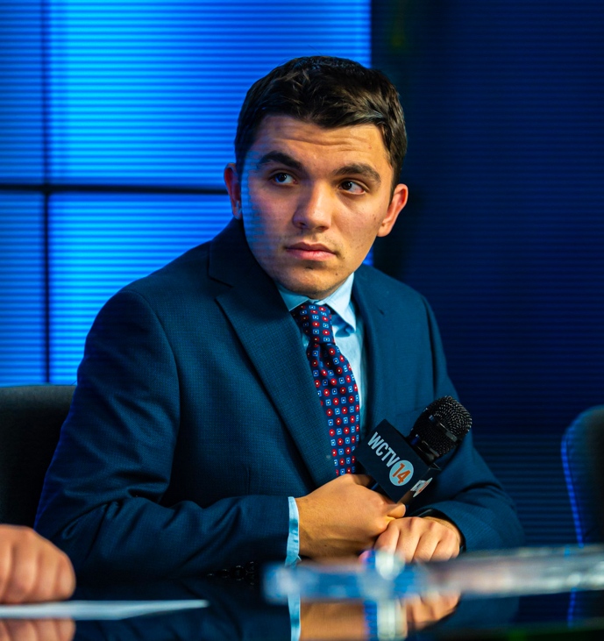
Anthony DiFilippo  Broadcasting & Sports Media | Multimedia Journalist & Storyteller  Expected Graduation: December 2025 | 4003 Chelstead Way  Murrysville, PA 15668  (412) 848-3239  anthonydifilippo23@gmail.com
EDUCATION  Waynesburg University, Waynesburg, PA— B.A. Communication (Sports Announcing), Minor Journalism  AUGUST 2022 - DECEMBER 2025  Assistant GM, WCTV | Assistant Sports Editor, Yellow Jacket | Producer, Plead Your Case  Franklin Regional High School, Murrysville, PA — High School Diploma  EXPERIENCE  The River Network, Ohio Valley— Freelance Broadcaster  Sepetember 2025 - PRESENT  Doing play-by-play for multiple Ohio Valley Athletic Conference football games during the 2025 high school football season  Pittsburgh Penguins/105.9 the X, Pittsburgh, PA —Radio Network Intern  JANUARY 2025- APRIL 2025  Produced pregame and postgame content; operated audio board for live game broadcasts  Tribune-Review, Greensburg, PA — High School Sports Staff Writer  AUGUST 2021 - APRIL 2025  Wrote weekly articles on Western PA high school sports, published in print and online  Nexstar Media, WKRG News 5, Location — News Intern  MAY 2024 - JULY 2024  Rotated through newsroom roles, writing web and broadcast content; created and recorded standups  WVRC Media/Pony League World Series, Washington, PA — Audio Technician Assistant and Camera Operator  AUGUST 2023 - AUGUST 2024  Installed and monitored microphones; handled troubleshooting and filled in operating the low first base camera  Greene Sports, Waynesburg, PA— Camera Operator  SEPTEMBER 2023-NOVEMBER 2024  Operated camera for high school sports broadcasts; improved production quality and efficiency  Iron and Oil Baseball, Butler, PA — Play-by-Play Announcer  JUNE 2023 - JULY 2023  Broadcasted 15+ games, developed research and preparation routines for live play-by-play  City of Bridges and Cannonball Comin Podcast, Remote — Creator  FEBRUARY 2020 - MAY 2025  Created and hosted original sports podcasts featuring guests and multimedia expansion  Inside the Bucs Basement, Remote — Part-Time Contributor  AUGUST 2020 - MARCH 2022  Wrote opinion and analysis columns on the Pittsburgh Pirates to be consumed online  *References Available Upon Request* | SKILLS  -Storytelling & Writing  -Play-by-play, sports talk radio, live TV production, news packages, podcasts  -Camera operation, audio board operation, mic wiring, remote coordination  -Adobe Suite, Microsoft Apps, ENPS, Rundown Creator, Canva  -Producing, Editing, live event coordinating  AWARDS  Best in Category – 2020 DMAC Live Event  Best in Category – 2022 DMAC Newscast  Nomination- Telly’s: Best Sports Broadcast 2025

